Essay on The Lover
This is an essay on The Lover, reflecting on what you found the most compelling, explaining what you learned from it and how it helped you understand Islam. You must include a minimum of five Islamic keywords from the text that you incorporate into your essay. Make sure you bold type these keywords. Your essay should be at least three pages and no longer than five pages, double-spaced, 12-point Times New Roman font and must include Chicago Manual of Style footnotes.

Please use the PDF with the book and write the assignment regarding to the book.
The E-book is available in amazon, pay it and I will pay you later with the assignment payment.
The book name ( $4 on amazon )
Laury Silvers, The Lover (gripping historical mystery novel)

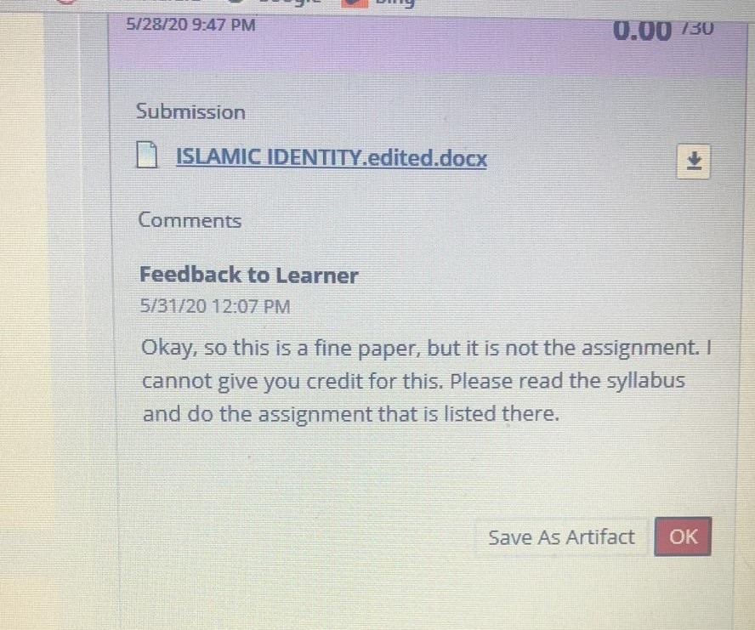
------------------------------------------
- I attach the previous work you did to the assignment.
- I attach an image of the professor respond with my grade.

